**topic: Othello by W. Shakespeare**

**Iago has not been the successful character of the play.**

## **source: https://medium.com/@shadderz01/iago-a-man-with-words-sharper-than-any-sword-4045f62261c7**

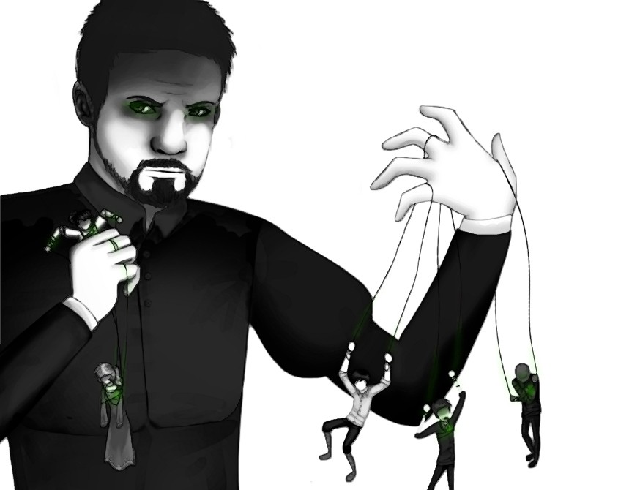

**Please, describe this picture and ist meaning!**

**source: https://www.sparknotes.com/shakespeare/othello/character/iago/**

The play ends in a spectacle of tragic violence:

“Othello’s suicide serves as a kind of trial in which he decides on and enacts a punishment for his crime of killing Desdemona. In his final speech, he explains how he hopes to be remembered, saying “When you shall these unlucky deed relate / Speak of me as I am” (5.2.)

Possibly the most heinous villain in Shakespeare, Iago is fascinating for his most terrible characteristic: his utter lack of convincing motivation for his actions. In the first scene, he claims to be angry at Othello for having passed him over for the position of lieutenant (I.i. 7–32). At the end of Act I, scene iii, Iago says he thinks Othello may have slept with his wife, Emilia: None of these claims seems to adequately explain Iago’s deep hatred of Othello, and Iago’s lack of motivation—or his inability or unwillingness to express his true motivation—makes his actions all the more terrifying. He is willing to take revenge on anyone—Othello, Desdemona, Cassio, Roderigo, even Emilia—at the slightest provocation and enjoys the pain and damage he causes.”

Please give the background of these descriptions.

Defend the statement that Iago has not been successful character of the play:

“Iago after all is not successful at the end – he destroyed everything without reaching his aim.”

**topic:**

**Iago has been the successful character of the play.**

**source: shmoop University**

# Bildergebnis für othello cartoon

# Source: https://www.sparknotes.com/shakespeare/othello/what-does-the-ending-mean/

The play ends in a spectacle of tragic violence:

Please describe it referring to Emilias, Othellos, Iagos and Cassios role.

Defend the statement that Iago has been successful character of the play:

“Iago has been so successful that Othello feels compelled to kill himself. Not only has Othello murdered his beloved wife, he also has to face the horrible truth that his suspicions of her adultery were completely unfounded.”