Topic: prejudices

A

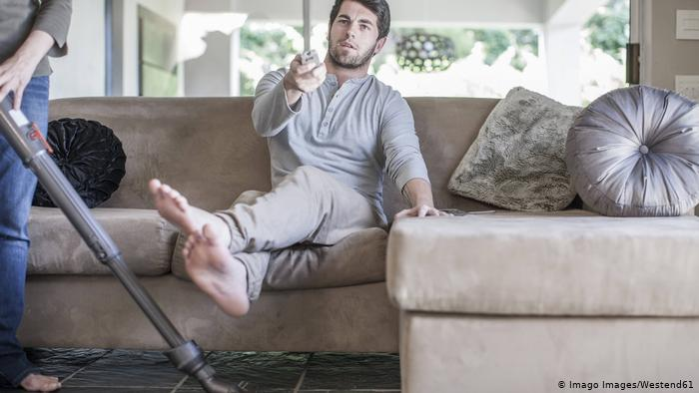

Though 76 percent of female and 88 percent of male marketers believe they avoid gender stereotypes when creating advertising, according to a global survey detailed in a Kantar report, researchers noted that ad targeting is still extremely skewed within specific product categories like baby products, laundry products and household cleaners — where females make up 98 percent of the targeted audience.

Why should they care?

Products like OB or lipsticks are made especially for women. Traditionally young women also take care of the babies. So why creating ads for minorities?

­­­­­­­­­­­­­_____________________________

B

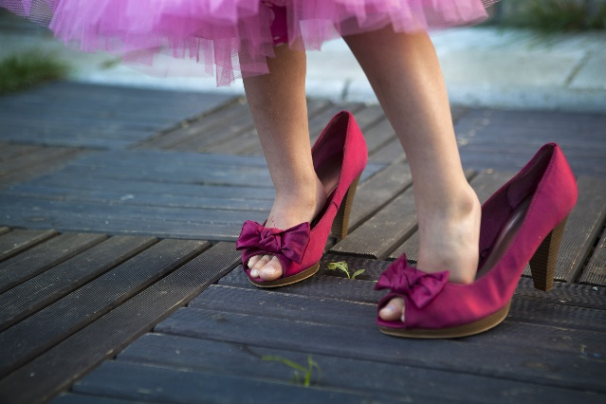

“While it is true that more women than men are primary grocery shoppers, it is strange that almost 100 percent of the people we talk to about baby products, laundry products and household cleaners are women”.

The data did find that most ads that run on TV (67%) — both digital (72%) and static (62%) — are targeted at both genders, but when ads are targeted at a specific gender, it’s usually women being targeted.

I think, it´s time to use advertising for both groups without role stereotypes.